Possible Accident Scenarios with the Domestic Robot

# Overview

We are going to explore the use of a Domestic robot in a nursing home. In particular, the robot will be used to assist a resident of the senior citizens home when they have fallen or need help. There are four networks in which this robot is connected: LOCAL, cellular, Intranet, and Internet. Each of them is a potential weakness for our robot. For instance, what if the robot loses communication with the charging station (LOCAL). What are the repercussions?

Figure 1 has a very bare bones network control structure for our robot. Each network control structure can be expanded separately, without regard to the other networks.



Figure 1 Communication system for Domestic Robot

# Environment Description

The robot is SLAM capable, i.e., it routinely maps the apartment. As an example, an apartment might contain one bedroom, one bathroom, a small living room and a small kitchen. We make the assumption that there are no stairs or step up/down areas in the apartment. As an example, a not to scale floorplan of my grandmother’s apartment at the Milwaukee Catholic Home (Figure 2) shows what a typical independent living apartment might look like. The floor plan is reasonably open, efficient and cleaned weekly by a maid. This last point is to emphasize that the room does not accumulate piles of junk. The room has an alarm to alert the monitoring station of an accident at the door and in the bathroom. This assumes the customer is able to get to those locations.



Figure 2 Floorplan example from Milwaukee Catholic Home.

# Networks Descriptions

This is not a hardware class, but a little explanation of each of the network communication systems (see Figure 1) responsibilities and functionality is appropriate.

## Local Network

The local can be a Bluetooth, 802.11, IR, etc. wireless networks. The hardware is not important, just the fact that the robot communicates with the base station and potential sensors. The distance the robot can be from the station and maintain communication is dependent on the network protocol chosen.

## Cellular Network

This network uses the cell phone attached to the robot. This network would be primarily used to contact persons on the customer’s In-Case-of-Emergency (ICE) list. This would potentially allow video phone and remote control of the robot.

## Intranet

This network maintains communication with the monitoring station. The assumption is that the robot is used in a retirement home with a receptionist. This receptionist will have a computer program that monitors all of the robots in the building, listening for any emergency signal from any robot in its intranet. (Should remote control be allowed here?)

## Internet

This is the method of contact for the doctor/hospital. It would generate an emergency communication to the doctor that would include time, location and other pertinent information. Should this alert would be sent after approval from local monitoring station?

# What the robot looks like (kind of)

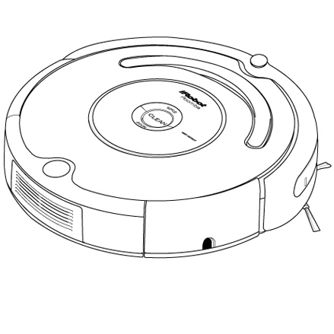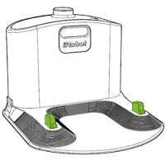

Basic Robot

Charging Base

Smartphone



Figure Robot system basic components

The robot, as stated earlier is about the size of a Roomba® with a connector for a smartphone. Since this is a research robot, Figure 3 gives a rough visualization of what the finished robot system might look like. It has a robot with a connector for a smartphone. It also has a charging base in which the robot will charge/rest/update when it is not active. There is no mention of external sensors, because that part of the system has not yet been finalized. The smartphone can be from any manufacturer and would be the client’s responsibility. (Could initially set phone manufacturer limits, such as iPhone or Android OS.)

# Assignment

See Table 1 to see for which scenarios you are responsible. This assignment is in two parts:

1. Your group (A) is to create a scenario in which the robot loses communication with one of the networks. This scenario will then be used by another group (B) to write their Accident Investigation. If your scenario is not complete enough, then the group writing the report (B) can interview the creators (A) to better flush out the story. Think of the Accident Scenario as a newspaper article that must answer the questions Who, What, When, Where, How and Why. The newspaper article is NOT the official accident investigation, it is a notification of an accident to the public. It should be at least two pages. The Investigation is done by the group B. **If group B does not have enough information, they will come back to “interview” group A. Group A will then need to update their “newspaper article”.** This is due in one week.
2. Group B is to “Investigate” the accident reported by Group A. This means interviewing, collecting and collating data for our fictitious accidents. You should then expand your control structure, examine failure points and make recommendations over the next 3 weeks. If the scenario presented to Group B is not detailed enough, “interview” Group A to expand the story. This is an investigation…

Table 1 Assignment for Accident Reporting and Report Writing

|  |  |  |
| --- | --- | --- |
| Scenario | Creates Accident Scenario | Writes CAST Report |
| LOCAL Network | Group 1 | Group 2 |
| Cellular Network | Group 2 | Group 3 |
| Intranet | Group 3 | Group 4 |
| Internet | Group 4 | Group 1 |

# Example of How an Accident Newspaper Article Might Begin

On April 1st, 2016 at the [Lake Haven Apartment Homes](http://havencommunities.com/) (1051 Columbia Memorial Pkwy, Kemah, TX 77565), the UHCL SLAMMIE Robot failed to communicate with (put your network here), causing Millie Kiesewetter (age 98) to receive no help. As a result, Ms. Kiesewetter died.